**Uni-Verse Project**

**Team 6**

Spring 2022

Joshua Boudria

Adam Emerson

Kevin Eduardo Flores

Ho Anh Tuan Vo

**Table of Contents**

| **Contents** | **Pg.** |
| --- | --- |
| *Table of Contents* …………………………………………………………….. | *1* |
| *Executive Summary* …………………………………………………….…… | *2* |
| *Context Diagram* ……………………………………………………………... | *3* |
| *UML-ClassDiagram-System* ………………………..………………………. | *4* |
| *UML-StateTransitionDiagram-Login …*…...………………………………... | *5* |
| *UML-SequenceDiagram-Student* …………………………………..………. | *6* |
| *UML-Activity Diagram-Organizer* ……………………………………...….... | *7* |
| *UML-StateTransitionDiagram-Event ………*……….….…………………... | *8* |
| *UML-ActivityDiagram-Settings* …………..……………………..…………... | *9* |
| *UML-CollaborationDiagram-Feed* .……..……………………...…………... | *10* |
| *UML-UseCaseDiagram-Interest …*……………………………..…………... | *11* |
| *UML-UseCaseDiagram-Notification* ………………..…………….………... | *12* |
| *UML-UseCaseDiagram-Schedule* *…..*……………………………………... | *13* |
|  |  |

**Executive Summary**

“Uni-verse” is a social networking application designed to assist students and organizers alike in creating, managing, finding, and attending on-campus events. The app’s core feature is a personalized “event feed” that will display upcoming events and activities relevant to each user. From the feed, users will be able to view details on each event and RSVP to events they wish to attend.

Uni-verse’s functionality will be subdivided between two types of users; Students and Organizers.

The feature-set tailored to Student users will include:

* The ability to create an editable profile page viewable by other students.
* Selection of personal interests in order to receive more relevant event recommendations.
* View dates, times, and locations, as well as RSVP to events.
* A customized calendar that will track upcoming RSVP’d events and a student’s course schedule.

If a user registers as an event Organizer, additional features will be available to them. The Organizer features include:

* The ability to create events, classify the type of event, and update their information as needed.
* Set events as public or private (Students need to be accepted to attend private events).
* Monitor student RSVPs to see the number of students interested in attending their event.

**Context Diagram**

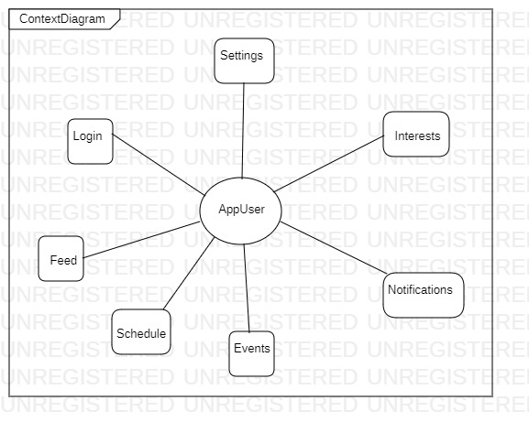

**UML Class Diagram**

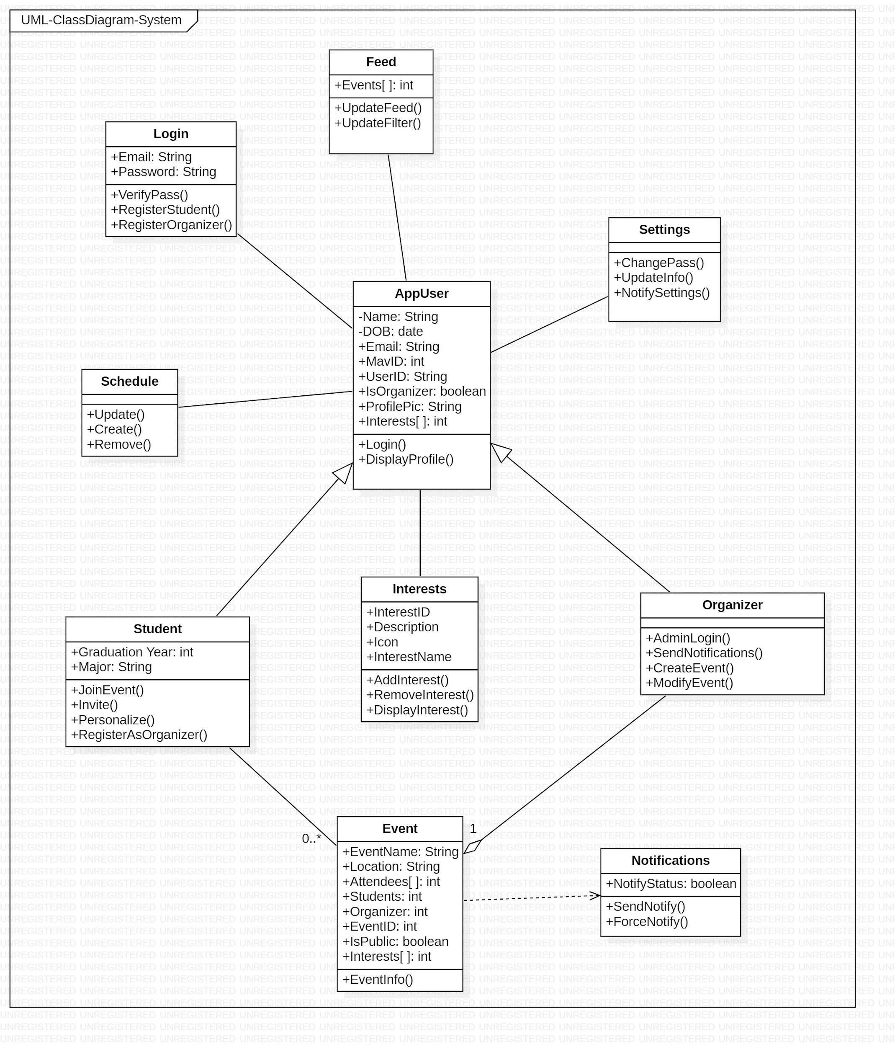

**UML-STD-Login**

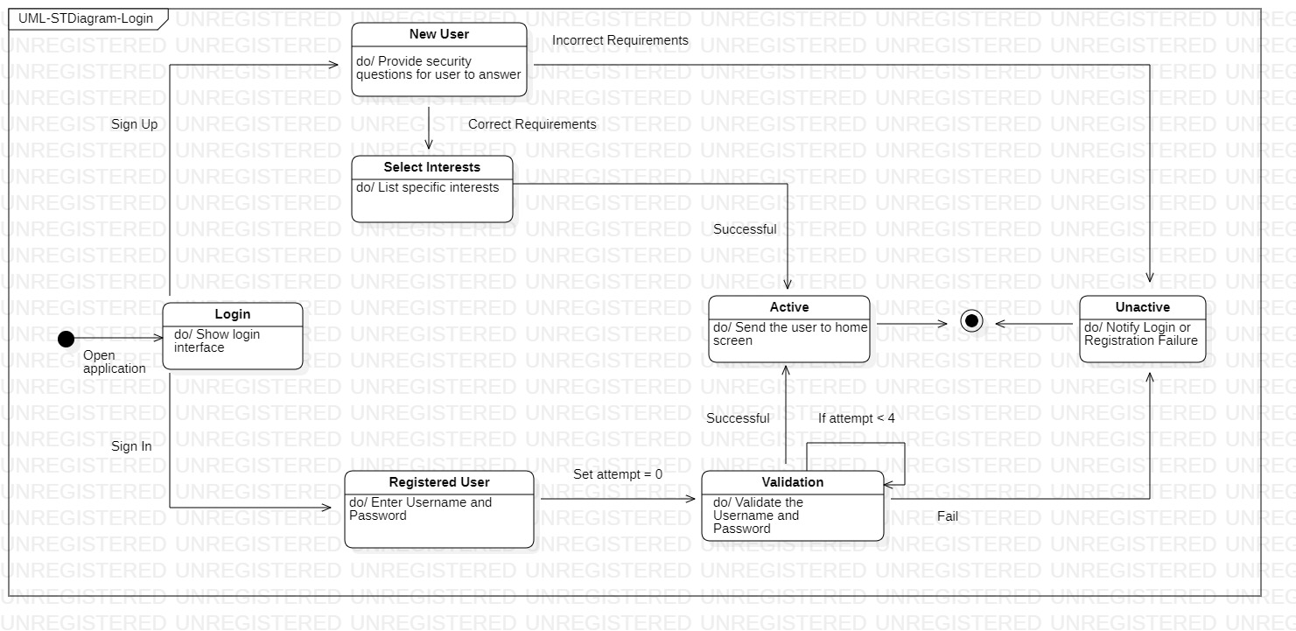

**UML-SequenceDiagram-Student**

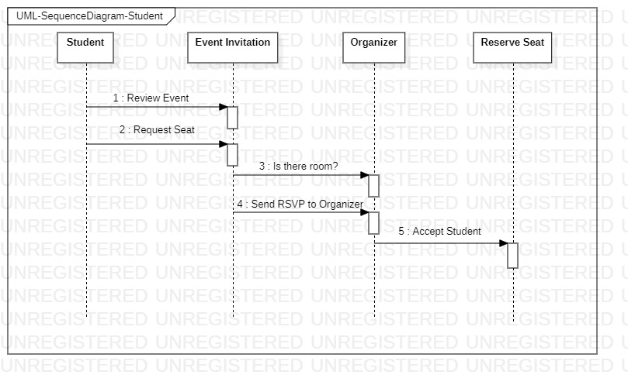

**UML-ActivityDiagram-Organizer**

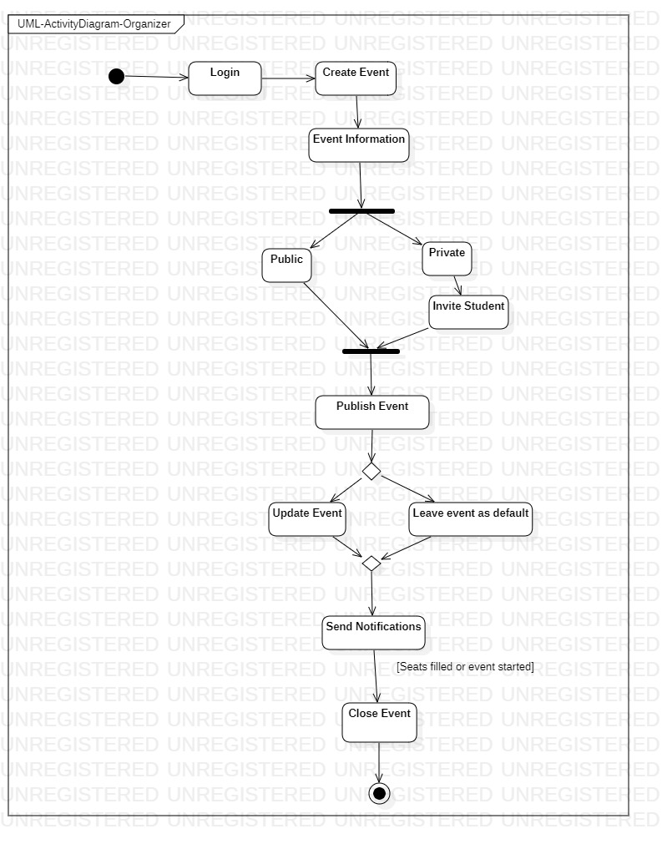

**UML-STDiagram-Event**

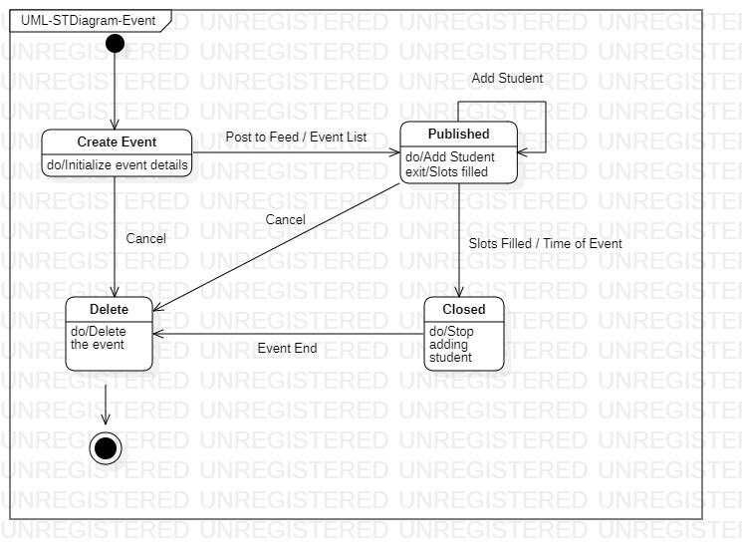

**UML-ActivityDiagram-Settings**

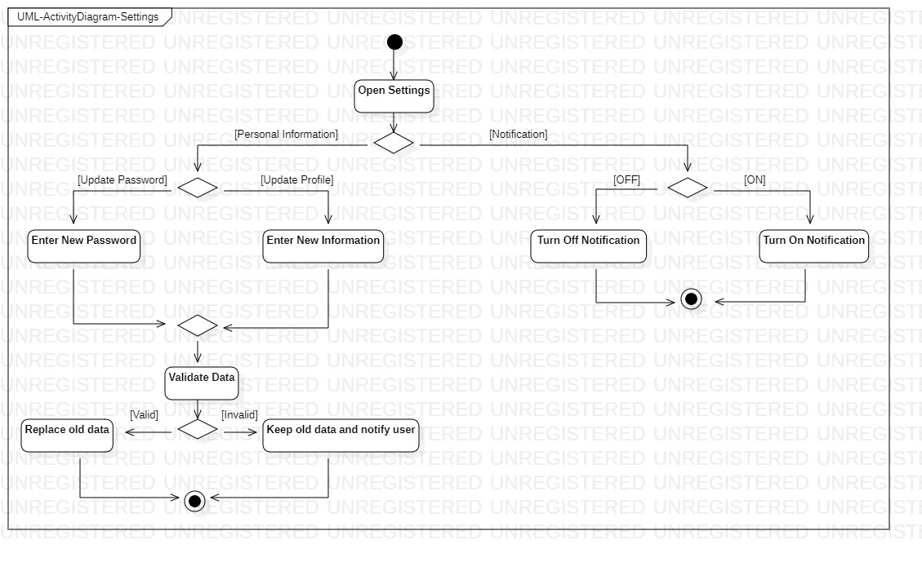

**UML-CollaborationDiagram-Feed**

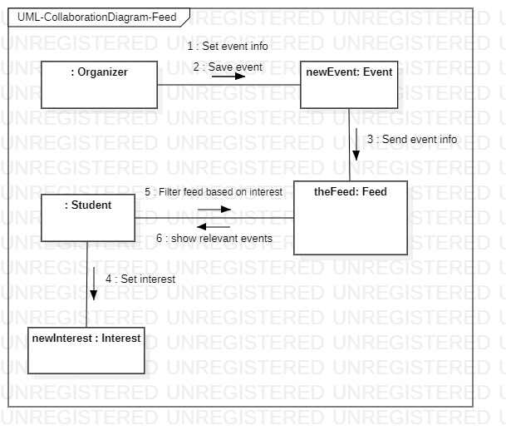

**UML-UseCaseDiagram-Interest**

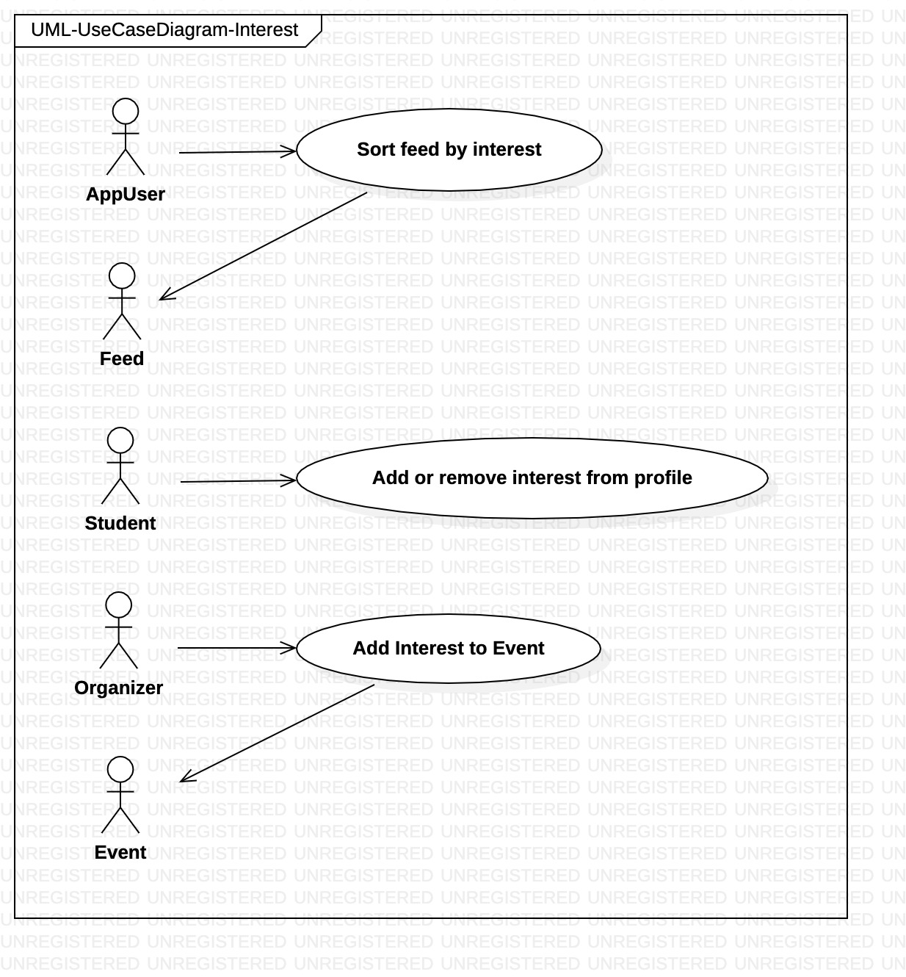

**UML-UseCaseDiagram-Notification**

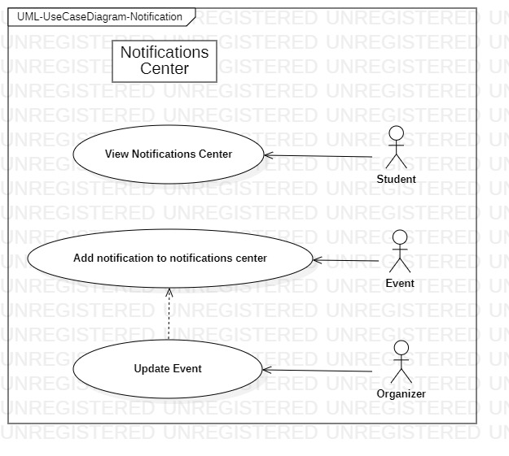

**UML-UseCaseDiagram-Schedule**

